MINI–PROJECT ASSIGNMENT
NAME: THEODORE AWARE
USERNAME: thw24pqy
ID: 500751274
1. Title and Author
Title: Unveiling the Wisdom of African Folktales: “A Natural Language Processing (NLP) Analysis of Ananse, the Cunning Spider and Beyond”
Author: Theodore Aware

2. Contents
- Title and Author
- Contents
- Introduction
- Corpus
- Documentation
- NLP Techniques used
- Results and Analysis
- Conclusion
- Discussion

3. Introduction
Natural Language Processing (NLP) bridges the gap between human language and computational systems. This mini project explores applying NLP techniques to analyze and derive insight from culturally significant text data. My corpus is titled “Afro Folktale Legends,” which centers around West African Folktales, specifically the tales of “Ananse”-the cunning Spider. It is centered on Ghanaian storytelling traditions, illustrating values and lessons passed down through generations.
The inclusion of the tale of the” Tortoise and the Hare” broadens the scope of the project by adding a universally resonant story with African variations. This tale is known for its moral lessons about humility and perseverance, and provides an ideal lens through which to analyze linguistics and recurring motifs. The project not only celebrates the rich storytelling traditions of Africa but also demonstrates the power of NLP methods, such as Text preprocessing, Parts of Speech (POS) tagging, and word frequency analysis, to enhance our understanding of cultural narratives.
By using NLTK and Python-based libraries, the project cleans and prepares the text corpus, paving the way for deeper analysis. Through the work, I aim to uncover the thematic essence of the tale, such as the value of wisdom, humility, perseverance, cleverness, and storytelling. This project serves as a testament to how technology can be used to preserve and interpret cultural heritage in the digital age.

4. Corpus
The Corpus was manually compiled through direct collection from relevant text sources, ensuring accuracy and contextual integrity in the dataset. It consists of Afro-folktale legends, which are stories passed through generations, often carrying moral lessons and cultural themes. The text is a collection of oral traditions, mythological narratives, and wisdom tales featuring characters like Anansi, Tiger, Lion, and others.
My corpus is made up of 154,347 characters in original text, 142,381 in cleaned text, 36,004 words, and 2707 sentences. Indicating that it is substantial in size. It also uses simple, conversational storytelling with recurring characters and motifs. The high frequency of certain words suggests repeated storytelling patterns. Afro-folktale legends often focus on trickster figures, wisdom, and survival, making the corpus a valuable resource for studying oral tradition and storytelling dynamics. The tales reflect cultural themes of resilience, cleverness, and moral lessons commonly found in African folktales.
Due to the relatively large nature of the corpus, there was a presence of some frequent words that may not carry any meaning on their own. Analyzing the corpus matters because it helps identify storytelling patterns in folktales, and it allows for linguistics and thematic analysis, which is how characters interact or how wisdom is conveyed

5. Documentation
This project explores the NLP techniques applied to West African Folktales, particularly Anansi stories: the cunning Spider and the broader African storytelling traditions. The goal is to analyze textual patterns, uncover linguistic structures, and derive insight from culturally rich narratives using Python-based NLP methods. The program processes the Afro-Folktale Legends corpus using NLTK and other Python libraries, transforming raw text into structured information.
The dataset is prepared by cleaning and preprocessing the folktale using techniques such as tokenization, Stopword removal, and lemmatization. This extracts key linguistic features such as parts of speech (POS) tagging and word frequency analysis to identify common themes and motifs. The output is visualized using a word distribution to highlight prominent characters (example “Anansi” and recurring storytelling elements.
This project demonstrates how NLP can preserve and analyze traditional narratives, bridging computational linguistics with cultural heritage by applying advanced text methods.
Processed text data is stored, ensuring that findings can be referenced for further NLP applications. The study offers a structured data-driven perspective on folklore, wisdom, and storytelling traditions passed down through generations.

6. NLP Techniques used
The code employs different Natural Language processes to analyze and preprocess the text corpus. Below are the text processing methods used. The preprocessing steps ensured that my text corpus was clean and ready for analysis, improving the quality and relevance of the data.
Tokenization: Word_tokenize, splits text into individual words.
Sent_tokenize splits text into sentences.
Stopwords removal: Stopwords. Words (‘english’) are used to filter out common words (‘the’, ‘is’,’ and’) that do not add any significant meaning to the text.
Punctuation removal: Filter out all punctuation using the string_punctuation module. Eliminating punctuation and non-alphanumeric characters to focus on meaningful content.
Lemmatization: WordNetLemmatizer is used to reduce words to their base form (running ->run, eating -> eat….), reducing inflected words to their root word.
Word Frequency Analysis: Word_counts enumerates the number of cleaned words in the text. This displays the 20 most common words alongside the total word and sentence count.
Parts of Speech (POS) Tagging: uses nltk.pos_tag(‘cleaned_words) to label each word with its grammatical category (nouns, verbs, adverbs…)
Text Data Storage: Saves processed words into a file (Cleaned_words_3.txt).
Data Visualization: A word cloud is generated using the wordcloud module to visually highlight the most frequent words in the text. The word cloud is displayed and saved as an image (wordcloud.jpeg)

7. Results and Analysis
The code dissects the text and brings out its core themes, and the output speaks volumes about the cultural significance of Afro-folktale legends.
Dominance of Anansi: The most frequent word is Anansi, appearing 1457 times, making it the central figure in this collection of folktales. Anansi, the cunning spider, is a deeply rooted character in African folklore, symbolizing cleverness and survival. His prominence in the word cloud reinforces his role as the main protagonist.
Frequent verbs indicating Action: Words like said (430), went (116), shouted (111), got (105), came (103), ran (72), and ate (96) suggest a highly dynamic narrative. This indicates that the stories used for creating the corpus aren’t just descriptions; they are filled with movement, dialogue, and interactions.
Key Characters and Symbols: Certain figures emerge as central to the narratives shaping the moral fabric of the tales. Below, we explore the key characters and symbols that define these folktales and their significance.
Tiger (304) and Tortoise (86) – likely major characters in the stories, involved in conflicts or lessons.
Lion (74) and Goat (80) – symbolizing power, wisdom, and trickery.
King (71) and House (74) – perhaps recurring motifs tied to authority and domestic life.
Yam (70) and Food (68) – food often plays a symbolic or survivalist role in folktales.
#20 most common words
Most common words:
Total words: 36004
Total sentences: 2707
Anansi: 1457
said: 430
Tiger: 304
went: 116
shouted: 111
got: 105
came: 103
ate: 96
tortoise: 86
Goat: 80
back: 77
tree: 76
Lion: 74
house: 74
Tacoomah: 74
ran: 72
king: 71
yam: 70
food: 68

#Wordcloud display output
The word cloud message visualization confirms what the data suggests - Anansi as the heart of the stories, surrounded by action and interactions with other creatures. The imagery captures the rhythm of folklore, heroes, challenges, wisdom, and survival.
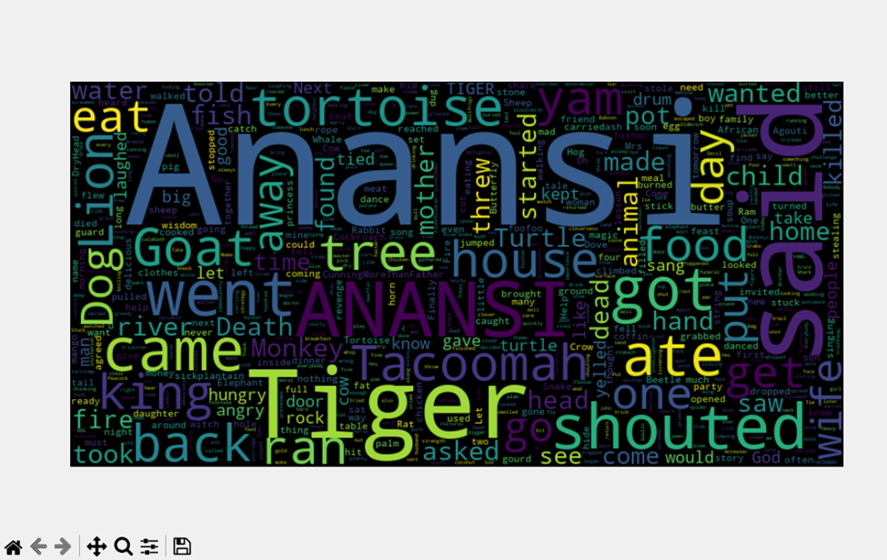

8. Conclusions
The code uncovers the essence of storytelling through computational analysis. In literature, patterns in word frequency help us understand narrative focus, themes, and cultural values. This approach is useful for researchers, storytellers, and anyone looking to study text with a fresh perspective.
The script essentially cleans, analyzes, and visualizes textual data, making it useful for tasks such as;
- Understanding dominant themes in the text
- Exploring word frequency trends
- Generating insight from textual data

9. Discussion
This analysis bridges data science and cultural storytelling, showing that Afro-folktales are deeply thematic, action-driven, and centered around power struggles. Anansi’s presence dominates the narratives, reinforcing his cultural significance as a trickster, while themes of food, leadership, and survival showcase traditional concerns. Beyond word frequencies, future investigations can uncover relationships between characters, emotional tones, and moral lessons embedded within these tales. This study highlights the power of computational tools in understanding folktale, proving that ancient stories still have much to teach us, especially when viewed through a modern analytical lens.
The technique of word frequency analysis has limitations in analyzing text data, even though it provides valuable insights, they don’t tell the whole story. Further studies can focus on contextual relationships, tone, and sentiment analysis to link positive and negative emotions. Investigating whether words tied to Anansi or Tiger signal positive or negative narratives. Comparative analysis can be employed to examine folktales from other cultures and reveal either similarities or differences in storytelling styles and themes. Other studies can also focus on narrative mapping, tracking the progression of conflicts and resolutions within the tales.
These findings highlight how Anansi’s character dominates the narrative, serving as cultural anchor for themes of wit, survival, and power struggles. The energetic storytelling style, reliance on animal symbolism, and emphasis on leadership all point to the rich, dynamic nature of Afro-folktales.

Appendix: Source code (full listing)
“””
ICE-4721-0 Natural Language Processing Mini Assignment
Author: Theodore Aware
Student ID: 500751274
Date: 01 May 2025
Description: This script processes and analyzes a corpus for an NLP task
Version: 1.0
Dependencies: nltk, re, pandas
“””

import nltk
from nltk.tokenize import word_tokenize, sent_tokenize
from nltk.corpus import stopwords
from collections import Counter
from nltk.stem import WordNetLemmatizer
import matplotlib.pyplot as plt
import re
from matplotlib import style
style.use('fivethirtyeight')
nltk.download('stopwords')

#nltk.download('punkt')
#load the text corpus
with open('Afro_folktale_legends.txt', 'r', encoding = 'utf-8') as file:
text = file.read()

# Tokenize the text into words and sentences
words = word_tokenize(text)
sentences = sent_tokenize(text)

# Remove punctuation from the text
stopwords = set(stopwords.words('english'))
filtered_words = [word for word in words if word.lower() not in stopwords]
#remove punctuation

# Perform stemming using NLTK's WordNetLemmatizer
nltk.download('wordnet')
lemmatizer = WordNetLemmatizer()
lemmatized_words = [lemmatizer.lemmatize(word) for word in filtered_words]

remove_special_characters = re.compile(r'[^a-zA-Z0-9\s]') #remove special characters
#remove special characters from the lemmatized words
lemmatized_words = [remove_special_characters.sub('', word) for word in lemmatized_words]
#remove empty strings from the lemmatized words
lemmatized_words = [word for word in lemmatized_words if word] #remove empty strings

cleaned_words_1 = [words.strip('.,!:;\'"\'"/ ') for words in lemmatized_words] #ensure that the words are stripped of punctuation and whitespace
#save the cleaned words to a text file
with open('cleaned_words_3.txt', 'w',encoding = 'utf-8') as file:
print(cleaned_words_1, file=file)

# Count the frequency of each word
word_counts = Counter(cleaned_words_1)

# Print the most common words and their frequencies
print("Most common words:")
print("Total words:", len(words))
print("Total sentences:", len(sentences))
for word, count in word_counts.most_common(20):
print(f"{word}: {count}")

#Word cloud visualization
# Create a word cloud from the word frequencies
from wordcloud import WordCloud
wordcloud = WordCloud(width=800, height=400, background_color='black', max_words = None).generate_from_frequencies(word_counts)
plt.figure(figsize=(10, 6))
plt.imshow(wordcloud, interpolation='bilinear')
plt.imsave('wordcloud.jpeg', wordcloud, format='png')
plt.axis('off')
plt.show() # Display the word cloud

Declaration and Unfair Practice
Plagiarism and Unfair Practice Plagiarized work or work deemed an example of academic misconduct will be given a mark of zero. Remember when you submit, you agree to the standard agreement: This piece of work is a result of my work, except for a group assignment for which approved collaboration has been granted. Material from the work of others (from a book, a journal, or the Web) used in this assignment has been acknowledged, and quotations and paraphrasing have been suitably indicated. I appreciate that to imply that such work is mine could lead to a nil mark, failing the module, or being excluded from the University. I also testify that no substantial part of this work has been previously submitted for assessment.

